**Performance Test for BlacklistedWords**

Test Summary:

|  |  |  |  |
| --- | --- | --- | --- |
| Kernel Request | createBlackListedWord | GetAllBlackListedWordByLangCode | Black listed word validation |
| Base URL | https://integ.mosip.io | https://integ.mosip.io | https://integ.mosip.io |
| Execution Window | 2018/12/31 09:51 AM IST to 2018/12/31 10:23 AM IST | | |
| Maximum User Load | 100 | 100 | 100 |
| Tool Used | Jmeter | Jmeter | Jmeter |
| Average Response Time | 640 | 911 | 714 |
| Throughput Achieved per sec | 11.46 | 11.40 | 11.46 |

**Transaction Summary:**

|  |  |  |  |  |  |  |  |
| --- | --- | --- | --- | --- | --- | --- | --- |
| API Request | #Sample | Average | 90% line(ms) | Min(ms) | Max(ms) | Error% | Throughput |
| createBlackListedWord | 25634 | 640 | 996 | 62 | 42013 | 0.39% | 11.46 |
| GetAllBlackListedWordByLangCode | 25603 | 911 | 1219 | 62 | 42015 | 0.00% | 11.40 |
| Black listed word validation | 25566 | 714 | 1063 | 60 | 42063 | 0.01% | 11.46 |
| Service to save Device Type | 62256 | 398 | 376 | 62 | 42012 | 0.01% | 27.88 |

**Blacklisted Words Controller:**

Response Times Over Time

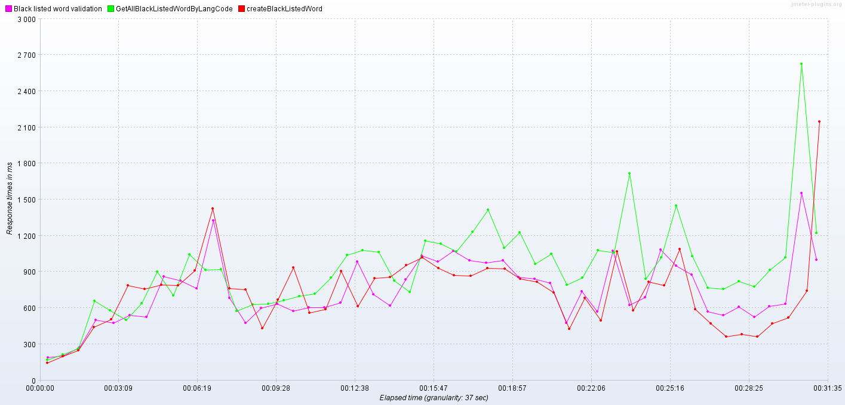

Bytes Throughput Over Time (bytes/sec)

